ASSIGNMENT – 7

- Design an ER diagram for an application that models a hospital doctors treat patients, prescribe tests, monitor progress etc. Analyse the requirements by identifying the entities, attributes, relationships, keys, constraints etc. Apply extended entity-relationship features to the design. Defend your design with proper assumptions and justifications. Map the ER model into a relational model.

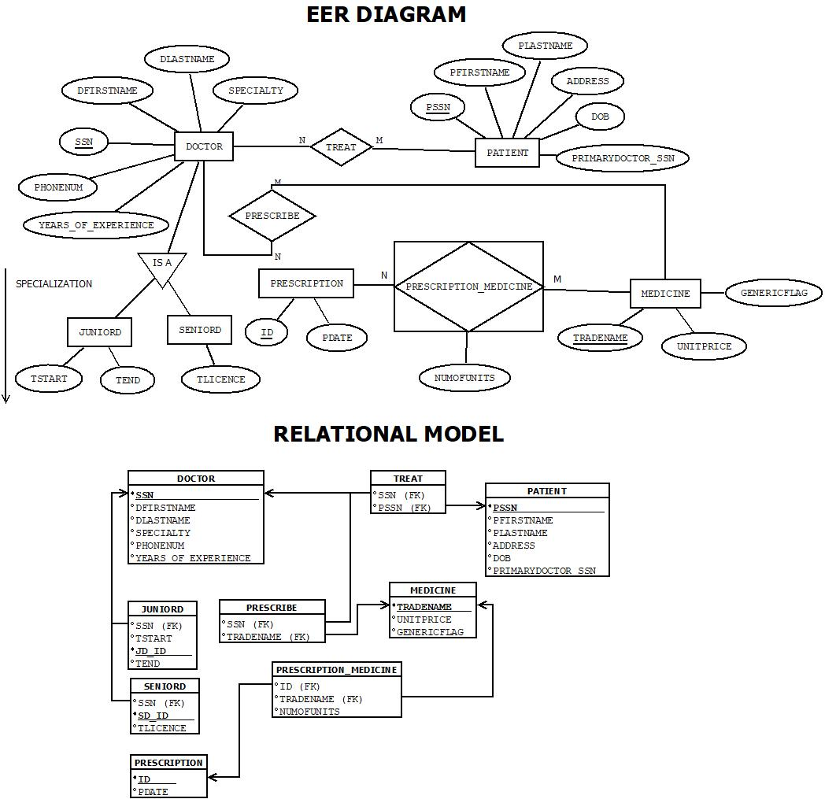

ASSUMPTION: -

- Doctor (SSN, DFIRSTNAME, DLASTNAME, SPECIALTY, PHONENUM, YEARS_OF_EXPERIENCE) is the parent entity with specializations into JUNIORD and SENIORD.
- JuniorD has attributes (SSN, TSTART, TEND, TLICENCE), and SeniorD has (SSN, SD_ID, TLICENCE); both are subtypes of Doctor.
- Patient (PSSN, PFIRSTNAME, PLASTNAME, ADDRESS, DOB, PRIMARYDOCTOR_SSN) is related to Doctor via PRIMARYDOCTOR_SSN.
- Medicine (TRADENAME, UNITPRICE, GENERICFLAG) stores information about medicines prescribed.
- Prescription (ID, FDATE) records prescriptions made by doctors.
- Prescription_Medicine (ID, TRADENAME, NUMOFUNITS) represents the medicines included in a prescription.
- Treat (SSN, PSSN) is a many-to-many (M:N) relationship between Doctor and Patient.
- Prescribe (SSN, TRADENAME) is a many-to-many (M:N) relationship between Doctor and Medicine.
- Prescription_Medicine is a many-to-many (M : N) relationship between Prescription and Medicine.
- Cardinalities:
- One doctor can treat many patients, and one patient can be treated by many doctors (M : N).
- One doctor can prescribe many medicines, and each medicine can be prescribed by many doctors (M : N).
- One prescription can include many medicines, and each medicine can appear in many prescriptions (M : N).
- One patient has one primary doctor (1:1).

- Create following tables, populate with data and construct queries (advanced) in SQL to extract information from the hospital doctor’s database:
- Doctor (SSN, FirstName, LastName, Specialty, YearsOfExperience, PhoneNum)
- Patient (SSN, FirstName, LastName, Address, DOB, PrimaryDoctor_SSN)
- Medicine (TradeName, UnitPrice, GenericFlag)
- Prescription (Id, Date, Doctor_SSN, Patient_SSN)
- Prescription_Medicine (Prescription Id, TradeName, NumOfUnits)
Create Tables and Insert values: -
- Doctor
create table doctor(
ssn varchar2(5) primary key,
FirstName varchar2(15) not null,
LastName varchar2(15) not null,
speciality varchar2(15),
YearsOfExperience number (2),
PhoneNum number (10) check (phonenum > 999999999 and phonenum < 10000000000)
);
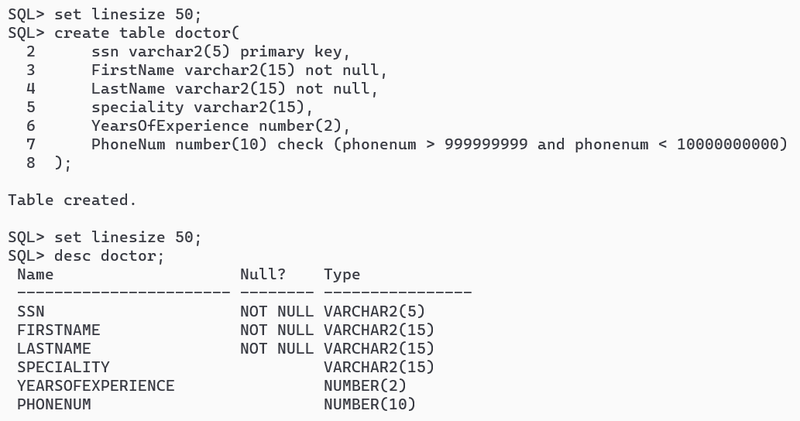
insert all
into doctor values ('D001', 'John', 'Smith', 'Cardiologist', 25, 9876543219)
into doctor values ('D002', 'Abhirup', 'Bag', 'Neurologist', 2, 9339316128)
into doctor values ('D003', 'Arnab', 'Chattopadhyay', 'Dermatologist', 1, 6296885021)
into doctor values ('D004', 'Abhrajit', 'Rath', 'Oncologist', 1, 7477516708)
into doctor values ('D005', 'Abhishikta', 'Roy', 'Cardiologist', 2, 8972505145)
into doctor values ('D006', 'Parna', 'Roy', 'Gynologist', 2, 9782647517)
select * from dual;
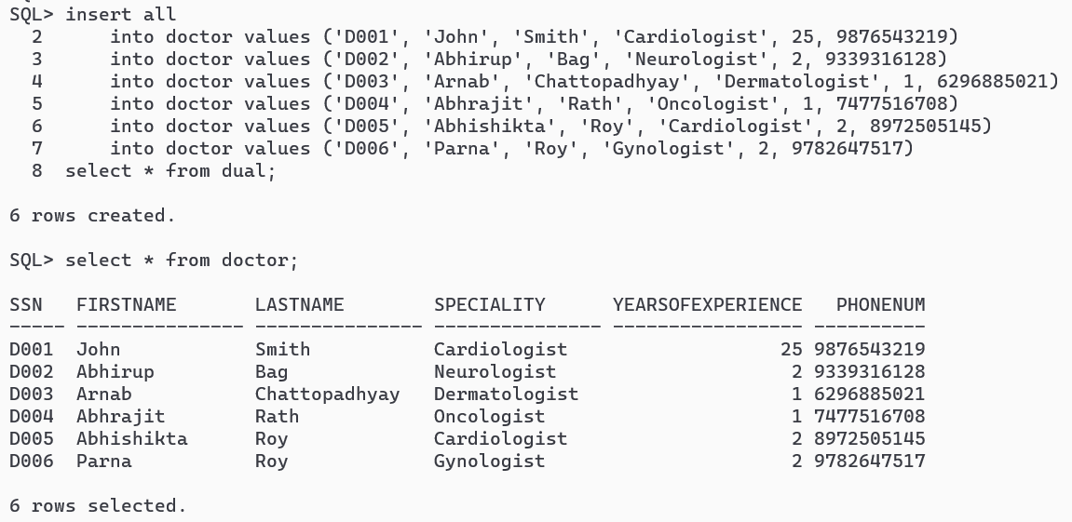
- Patient
create table patient (
ssn varchar2(5) check (ssn like 'P%') primary key,
FirstName varchar2(15) not null,
LastName varchar2(15) not null,
address varchar2(20),
dob date,
primary_doctor_ssn varchar2(5) references doctor(ssn) on delete cascade
);
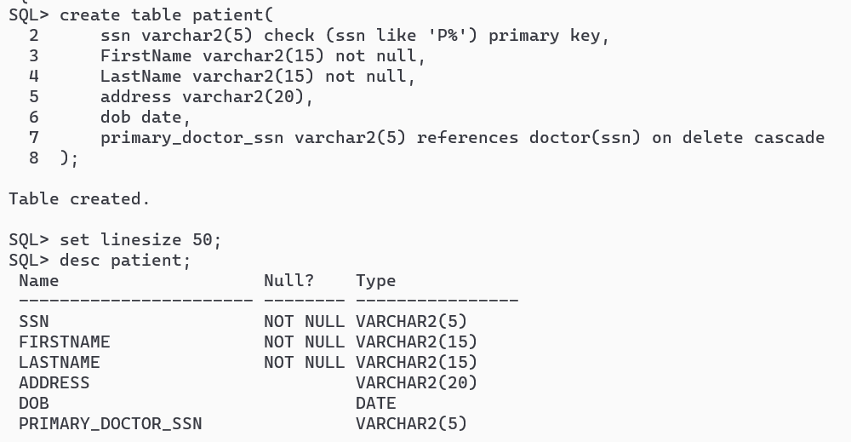
insert all
into patient values ('P001', 'Sayantan', 'Sarkar', 'Lahore', to_date('29-02-1948', 'DD-MM-YYYY'), 'D001')
into patient values ('P002', 'Arpan', 'Kundu', 'Bora', to_date('05-04-2002', 'DD-MM-YYYY'), 'D001')
into patient values ('P003', 'Sayan', 'Pal', 'Kalachhara', to_date('16-11-2003', 'DD-MM-YYYY'), 'D005')
into patient values ('P004', 'Souhit', 'Paul', 'Baruipara', to_date('10-08-2002', 'DD-MM-YYYY'), 'D002')
into patient values ('P005', 'Ajay', 'Bag', 'Krishnarampur', to_date('01-01-1977', 'DD-MM-YYYY'), 'D001')
select * from dual;
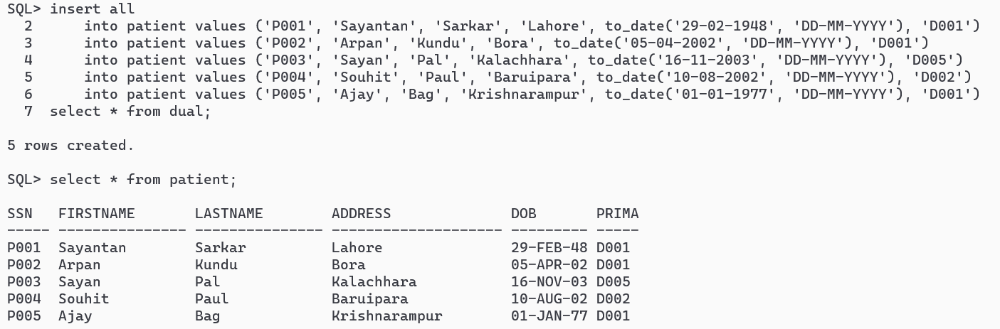
- Medicine
create table medicine (
TradeName varchar2(10) primary key,
UnitPrice number (5,2) not null,
GenericFlag varchar2(1) check (genericflag in ('Y', 'N'))
);
desc medicine;
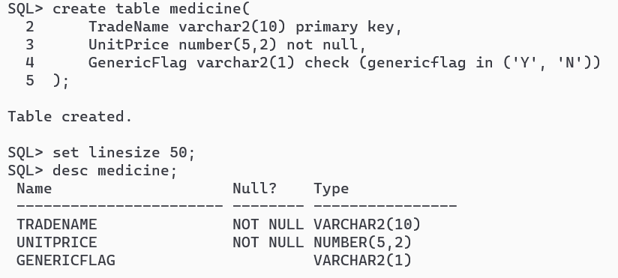
insert all
into medicine values ('Aspirin', '10.50', 'Y')
into medicine values ('Vitamin', '5.00', 'Y')
into medicine values ('ORS', '7.00', 'N')
into medicine values ('RantacD', '3.50', 'Y')
into medicine values ('Pyrigesic', '2.50', 'Y')
select * from dual;
select * from medicine;
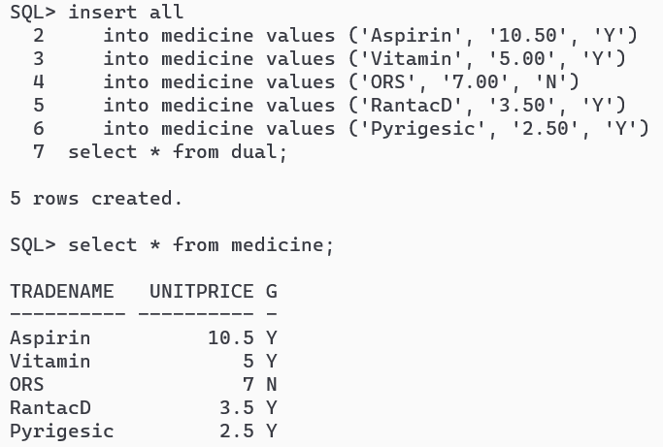
- Prescription
create table prescription (
Id varchar2(5) check (Id like 'PR%') primary key,
Doctor_ssn varchar2(5) references doctor(ssn) on delete cascade,
Patient_snn varchar2(5) references patient(ssn) on delete cascade
);
desc prescription;
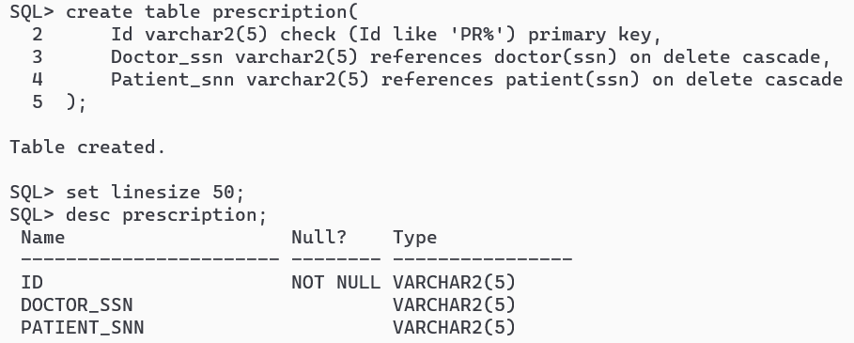
insert all
into prescription values ('PR001', 'D001', 'P001')
into prescription values ('PR002', 'D001', 'P002')
into prescription values ('PR003', 'D001', 'P005')
into prescription values ('PR004', 'D002', 'P004')
into prescription values ('PR005', 'D003', 'P001')
into prescription values ('PR006', 'D004', 'P002')
into prescription values ('PR007', 'D005', 'P003')
select * from dual;
select * from prescription;
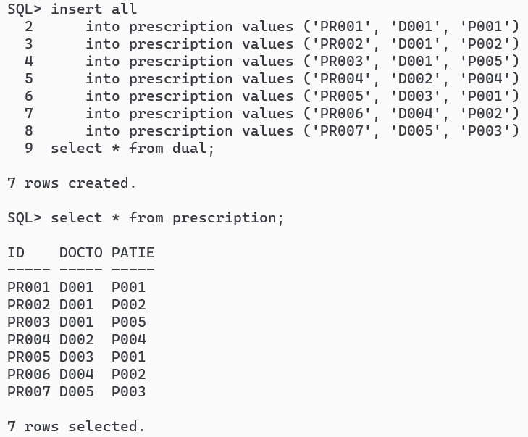
- Prescription_Medicine
create table Prescription_Medicine(
Prescription_Id varchar2(5) references prescription(Id) on delete cascade,
TradeName varchar2(10) references medicine(tradename) on delete cascade,
NumOfUnits number(5),
primary key (Prescription_Id, TradeName)
);
desc Prescription_Medicine;
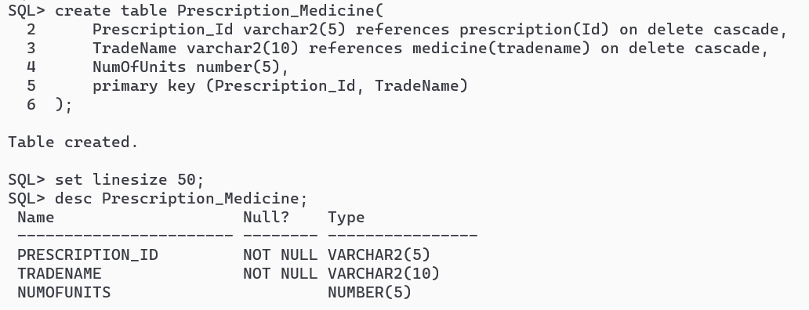
insert all
into Prescription_Medicine values ('PR001', 'Aspirin', 2)
into Prescription_Medicine values ('PR001', 'Vitamin', 1)
into Prescription_Medicine values ('PR002', 'RantacD', 10)
into Prescription_Medicine values ('PR003', 'Pyrigesic', 5)
into Prescription_Medicine values ('PR003', 'RantacD', 5)
into Prescription_Medicine values ('PR004', 'ORS', 4)
into Prescription_Medicine values ('PR005', 'Aspirin', 3)
into Prescription_Medicine values ('PR006', 'Vitamin', 7)
into Prescription_Medicine values ('PR007', 'ORS', 6)
select * from dual;
select * from Prescription_Medicine;
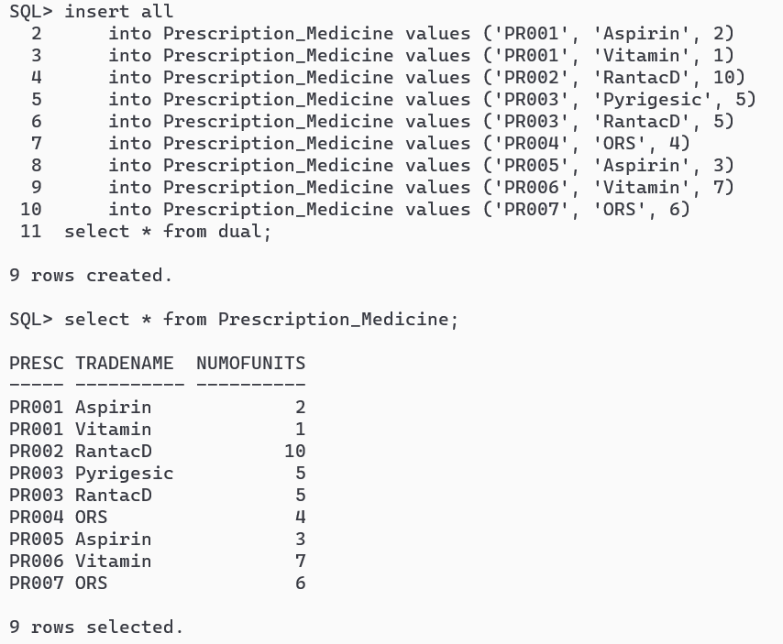
- SeniorD
create table SeniorD (
ssn varchar2(5) primary key,
TLicence varchar2(10),
foreign key (ssn) references doctor(ssn) on delete cascade
);
desc SeniorD;
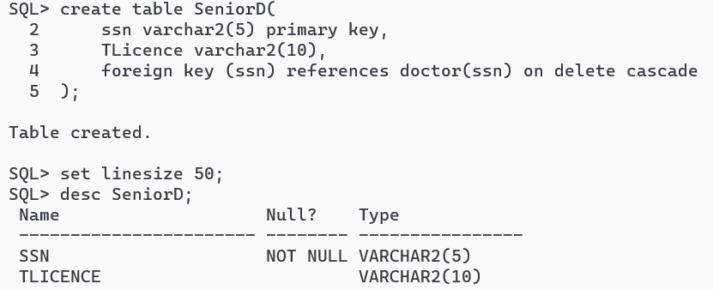
- JuniorD
create table JuniorD (
ssn varchar2(5) primary key,
TStart date,
TEnd date,
foreign key (ssn) references doctor(ssn) on delete cascade
);
desc JuniorD;
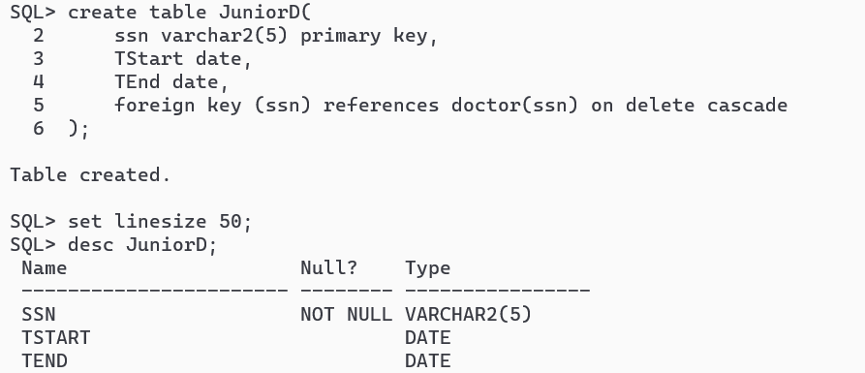
insert all
into SeniorD values ('D001', 'TL001')
into SeniorD values ('D002', 'TL002')
into JuniorD values ('D003', to_date('01-01-2025', 'DD-MM-YYYY'), to_date('31-12-2025', 'DD-MM-YYYY'))
into JuniorD values ('D004', to_date('01-01-2025', 'DD-MM-YYYY'), to_date('31-12-2025', 'DD-MM-YYYY'))
into JuniorD values ('D005', to_date('01-01-2024', 'DD-MM-YYYY'), to_date('31-12-2024', 'DD-MM-YYYY'))
into JuniorD values ('D006', to_date('01-01-2024', 'DD-MM-YYYY'), to_date('31-12-2024', 'DD-MM-YYYY'))
select * from dual;
select * from SeniorD;
select * from JuniorD;
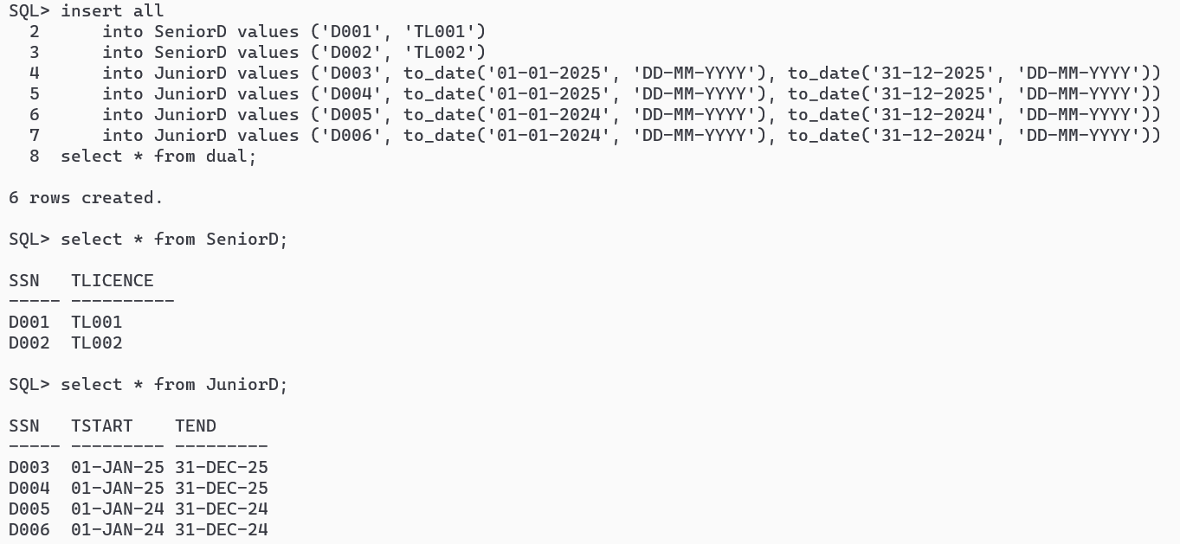
SQL QUERIES: -
-- 1. List the trade name of generic medicine with unit price less than $50.
select tradename from medicine where genericflag = 'Y' and unitprice < 50;
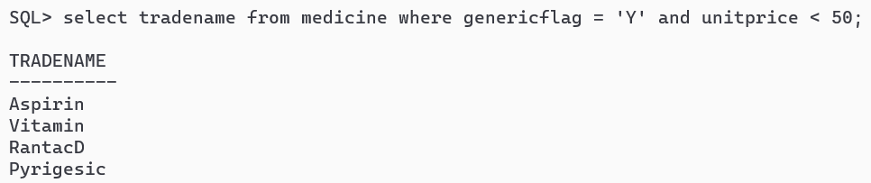
-- 2. List the first and last name of patients whose primary doctor named ʻJohn Smithʼ.
select d.firstname, d.lastname from
doctor d join patient p on d.ssn = p.primary_doctor_ssn
where d.firstname = 'John' and d.lastname = 'Smith';
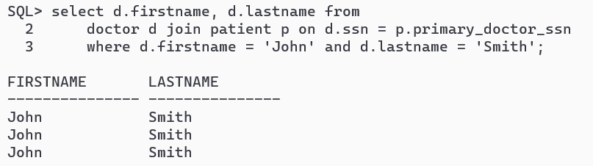
-- 3. List the first and last name of doctors who are not primary doctors to any patient.
select d.firstname, d.lastname from doctor d
where ssn not in (
select primary_doctor_ssn from patient
);
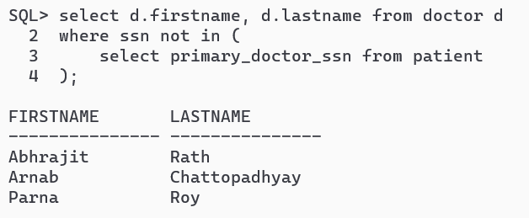
-- 4. For medicines written in more than 20 prescriptions, report the trade name and the total number of units prescribed.
select tradename from
(select tradename, count(prescription_id) as count
from prescription_medicine group by tradename)
where count > 20;
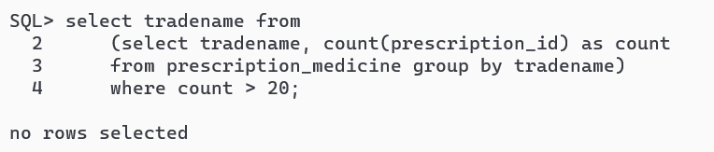
-- 5. List the SSN of patients who have ʻAspirinʼ and ʻVitaminʼ trade names in one prescription.
select patient_ssn from prescription where id in (
select prescription_id from prescription_medicine
where tradename = 'Aspirin' or tradename = 'Vitamin'
group by prescription_id having count(*)>1
);
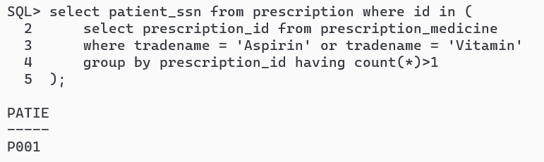
-- 6. List the SNN of distinct patients who have ʻAspirinʼ prescribed to them by doctor named ʻJohn Smithʼ.
select distinct p.patient_ssn from
doctor d join prescription p on d.ssn = p.doctor_ssn
join prescription_medicine pm on p.id = pm.prescription_id
where d.firstname='John' and d.lastname='Smith' and tradename='Aspirin';
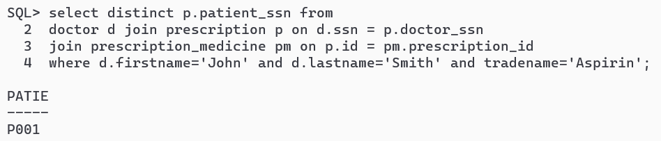

-- 7. List the first and last name of patients who have no prescriptions written by doctors other than their primary doctors.
select p.firstname, p.lastname
from patient p where ssn not in (
select patient_ssn from prescription
where doctor_ssn != p.primary_doctor_ssn
);

